Issues while installing docker and deploying a chaincode via running four peers.

List of Issues:
- COPY ISSUE: To deploy a chaincode within a container of a peer, we need to copy the file into that container. To copy it we should follow some commands.

- QUERY ISSUE: After performing init, invoke operations, while doing query the chaincode is taking time to return the queried result.

- IP ADDRESS: Inorder to run the application via postman we need to give the docker ip address instead of localhost in the app.js file.

- FUNCTION NOT FOUND ISSUE : While posting the invoke request from postman or cmd prompt we need to add another argument by giving exact function name.

===================================COPY ISSUE: =======================================

While copying file to container or from container to local machine we need to give right path which includes the container name. we should give appropriate name of the container.

Steps to follow while copying to container are below:
- To copy a file into container firstly we need to execute the docker container.
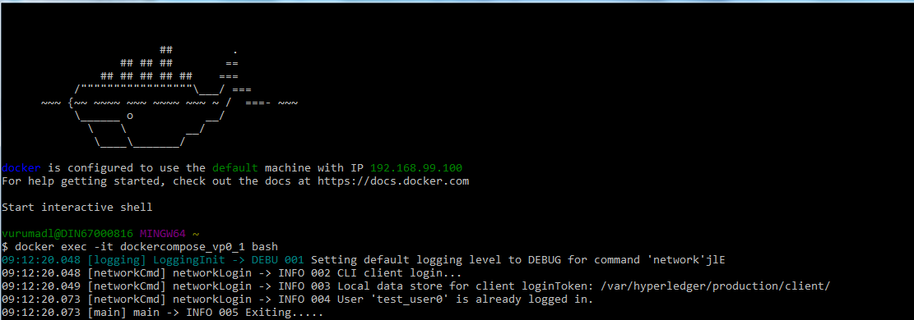
- After getting into the container create a folder anywhere within the fabric folder as below.
- In other terminal get into the folder where your file/chaincode is presnt in your local machine. In my it is ( c/Users/vurumadl/source-files ).
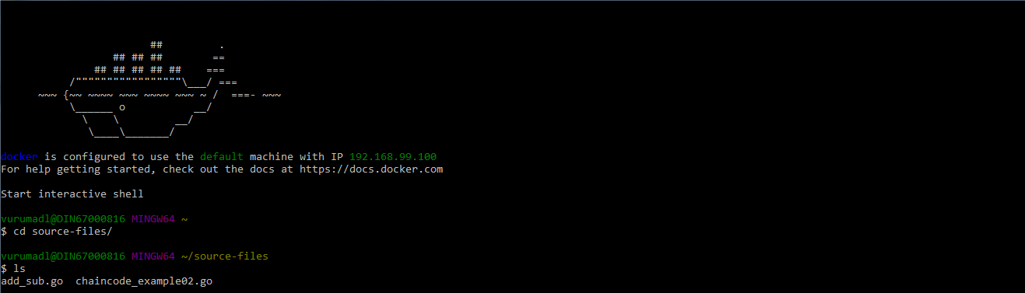
- NOTE: Now follow the below command to copy the file into the container.
- The command format is shown below
- docker cp [OPTIONS] CONTAINER:SRC_PATH DEST_PATH|-
- docker cp [OPTIONS] SRC_PATH|- CONTAINER:DEST_PATH
- Now go to the previous terminal and check whether it is moved to container or not. Check it by doing ls.

===================================QEURY ISSUE: ======================================

- When we try to query chaincode immediately after doing invoke, sometimes it gives a error saying could not find deployed chaincode.
- This is due to the deploy time that it takes .
- The error looks as below.
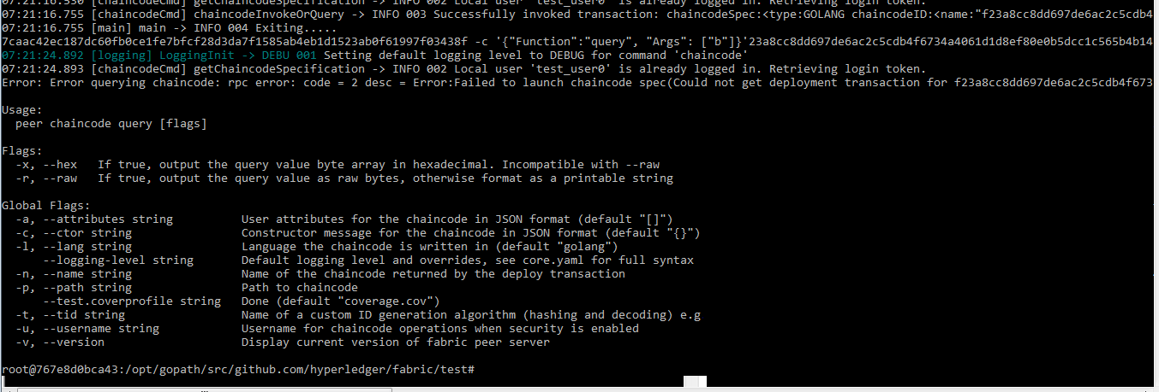

- The solution for this as of now is to wait for some time for the chaincode to get deploy ed.
- Then do the query. It will show the result.

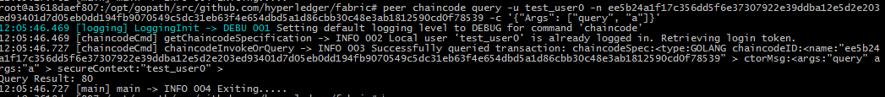

=================================== IP ADDRESS : ======================================

- When you your peers locally the you can give api_host as localhost in your app.js file. This will be like the below code.
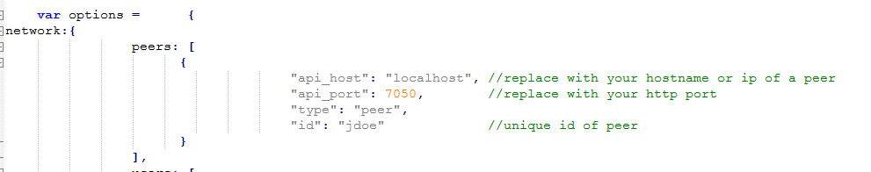

- But when you run your peers with in the docker then you have to give the ip address of docker as api_host in your app.js file.
- The docker ip is: 192.168.99.100
- This can be shown as below.

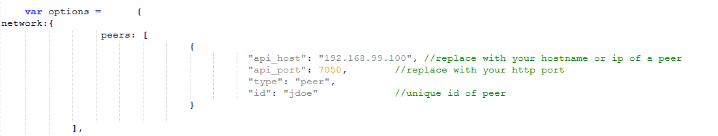

============================== FUNCTION NOT FOUND ISSUE: =============================

- When you are posting the invoke request from postman or docker command prompt if you don’t specify the function name it will throw function not found error.
- To rectify this we need to add function name to the arguments list and then post the request.
- This request can be shown below.

From docker command prompt:
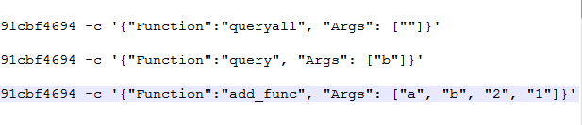
From postman:

Deploy:

{
"jsonrpc": "2.0",
"method": "deploy",
"params": {
"type": 1,
"chaincodeID":{
"name": "mycc",
"path": "github.com/hyperledger/fabric/examples/chaincode/go/chaincode_example02"
},
"ctorMsg": {
"function":"init",
"args":["a", "100", "b", "200"]
},
"secureContext": "test_user0"
},
"id": 1
}

Invoke:

{
"jsonrpc": "2.0",
"method": "invoke",
"params": {
"type": 1,
"chaincodeID":{
"name":"ee5b24a1f17c356dd5f6e37307922e39ddba12e5d2e203ed93401d7d05eb0dd194fb9070549c5dc31eb63f4e654dbd5a1d86cbb30c48e3ab1812590cd0f78539"
},
"ctorMsg": {
"function":"invoke",
"args":["invoke", "a", "b", "10"]
},
"secureContext": "test_user0"
},
"id": 3
}

Query:

{
"jsonrpc": "2.0",
"method": "query",
"params": {
"type": 1,
"chaincodeID":{
"name":"ee5b24a1f17c356dd5f6e37307922e39ddba12e5d2e203ed93401d7d05eb0dd194fb9070549c5dc31eb63f4e654dbd5a1d86cbb30c48e3ab1812590cd0f78539"
},
"ctorMsg": {
"function":"query",
"args":["a"]
},
"secureContext": "test_user0"
},
"id": 3
}

